9. Write a JavaScript program for Email validation. You can apply validation on the below
text questions to ensure they accept answers in a specific format.
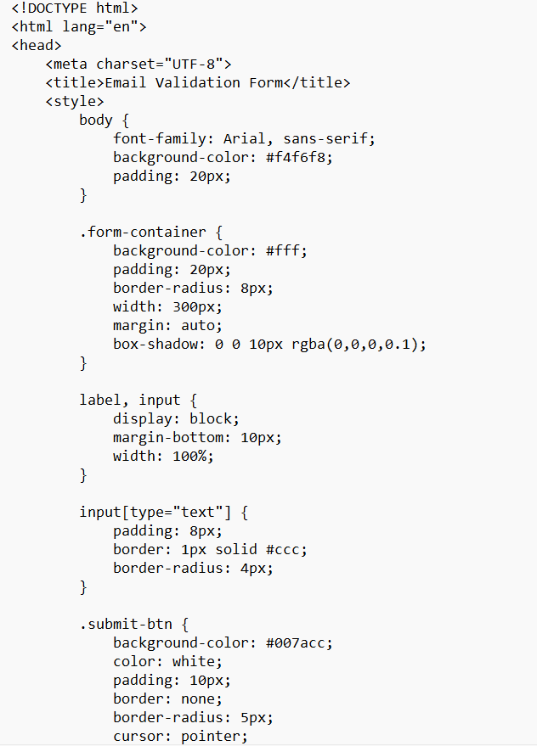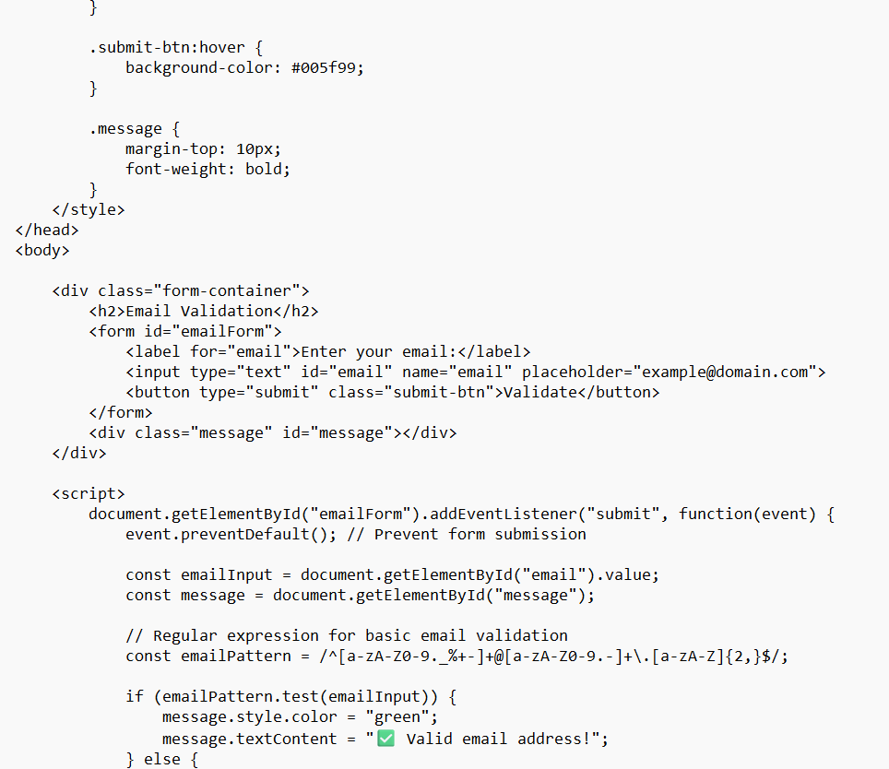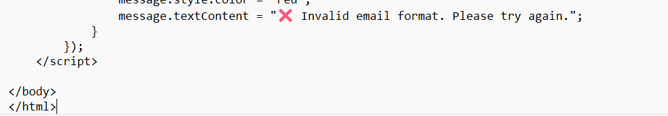output
